ORC Security Design Document

Author: Evosys Team

Creation Date: December 7, 2021

Last Updated: December 17, 2021

Document Ref:

Version: 4.0

**Approvals:**

oracle.gif

# Document Control

## Change Record

21

| Date | Author | Version | Change Reference |
| --- | --- | --- | --- |
| 02-12-2021 |  | 1.0 | Initial Draft |
| 7/12/21 |  | 2.0 | Updated following comments |
| 8/12/2021 |  | 3.0 | Updated Section 2.7 and added new section 2.11 based on comments |
| 17/12/2021 |  | 4.0 | Added 2.12 eQuest section. |
|  |  |  |  |
|  |  |  |  |
|  |  |  |  |
|  |  |  |  |
|  |  |  |  |
|  |  |  |  |
|  |  |  |  |
|  |  |  |  |
|  |  |  |  |

## Reviewers

| Name | Position |
| --- | --- |
|  | Data Team Manager & Solution Architect for ORC – ORC Project Team |
|  | Applications Team Manager |
|  | Application Analyst - ORC Project Team |
|  | BAU Oracle Reporting |
|  | Head of Business Systems/Project Board |
|  |  |
|  |  |
|  |  |

Contents

1 Document Control 2

1.1 Change Record 2

1.2 Reviewers 2

2 Security roles and Profiles 4

2.1 LBC Pending Worker Role 4

2.2 LBC Employee Role 5

2.3 LBC Contingent Worker (Non-Manager) 6

2.4 LBC Contingent Worker ( Manager) 7

2.5 LBC Hiring Manager 8

2.6 LBC Line Manager 10

2.7 LBC Collaborator 10

2.8 LBC Recruiter 11

2.9 LBC Recruiting Administrator 15

2.10 LBC Recruitment Reporting 15

2.11 Security Profiles for New Roles Created 15

2.12 EQuest 16

3 Open Issues 17

4 Closed Issues 18

# Security roles and Profiles

This document presents security landscape for Oracle Recruiting Cloud implementation Project. are currently live with HR, Self-service and Payroll modules and will be going live with ORC module in the same system, hence security design for Oracle Recruiting Cloud needs to adhere to existing security model in place for HCM and ERP modules. Security Workshops in HLA and CRP phases have been conducted and following security roles have been identified for Oracle Recruiting Cloud (ORC) implementation project. Some of the roles will be auto provisioned and some will need to be manually assigned to the users.

## LBC Pending Worker Role

**Role Name**: LBC Pending Worker

**Role Code**: LBC_PER_PENDING_WORKER_ABSTRACT_CUSTOM

LBC Pending worker Role is an Abstract Role(doesn’t need to be created a Data Role). This role is given to Pending worker which provides reduced access in self-service to Onboarding tasks only for pending worker new starters that are joining .

Once a candidate accepts the offer, the candidate is moved to hr using Move to HR action in ORC, this will trigger a Welcome email to prompt them to create a password and they can then complete their pre-hire onboarding tasks.

Pending worker can perform below actions using LBC Pending Worker Role:

* Perform onboarding tasks
* Access Family & Emergency Contact information
* Enter Bank Details & Personal Payment Method
* Enter New Starter Declaration information.

**Role Details:**

* LBC Pending Worker role is created by copying seeded Pending Worker Role. Please find below attached excel sheet with list of Privileges and Duty Roles



**Autoprovision Rule:** Please find below attached screenshot with mapping rule.

## LBC Employee Role

**Role Name**: LBC Employee

**Role Code**: LBC_PER_PENDING_WORKER_ABSTRACT_CUSTOM

**Inherited Job Role:** Employee Role

This role is already available to all the employees, but to use Oracle Recruiting Cloud functionality, additional roles and privileges have been added which are mentioned below. These additional roles and privilege will now allow the employee to access the Current Jobs Page which helps employees to perform below tasks

* Search for Internal Jobs
* Apply for Internal Jobs
* Accept Job Offers
* Share Jobs

**Role & Privileges added to Job Role ( Employee Role)**

Roles:

1. Access Internal Candidate Experience
2. Manage Onboarding by Worker
3. Use REST Service - Recruiting Hierarchy Lists of Values

Privileges:

1. Access Internal Candidate Experience
2. Use REST Service - Recruiting Hierarchy Lists of Values

**Autoprovision Rule:** Please find below attached screenshot with mapping rule.

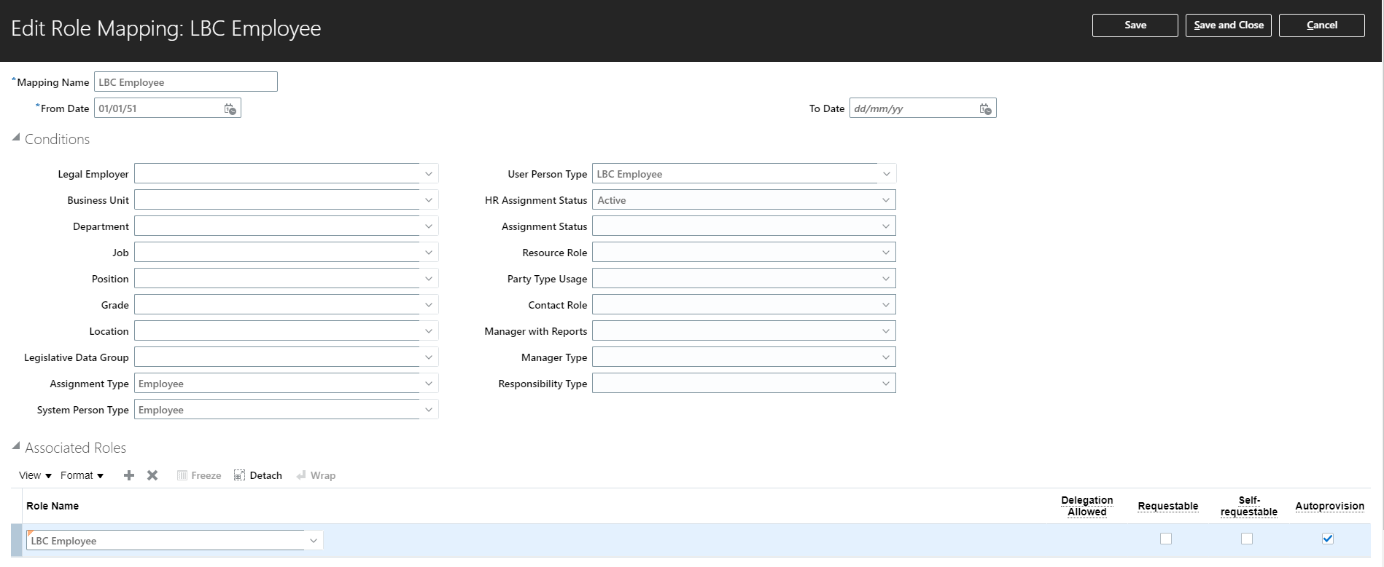

## LBC Contingent Worker (Non-Manager)

**Role Name**: LBC Contingent Worker (Non-Manager)

**Role Code**: LBC_CONTINGENT_WORKER_(NON-MANAGER)_DATA

**Inherited Job Role:** Employee Role

This role is already available to all the contingent workers, but to use Oracle Recruiting Cloud functionality additional roles and privileges have been added which are mentioned below. These additional roles and privilege will now allow the contingent workers to access the Current Jobs Page which helps contingent workers to perform below tasks

* Search for Internal Jobs
* Accept Job Offers
* Share Jobs
* Access Onboarding tasks

**Role & Privileges added to Job Role ( Employee Role)**

Roles:

1. Access Internal Candidate Experience
2. Manage Onboarding by Worker
3. Use REST Service - Recruiting Hierarchy Lists of Values

Privileges:

1. Access Internal Candidate Experience
2. Use REST Service - Recruiting Hierarchy Lists of Values

**Autoprovision Rule:** Please find below attached screenshot with mapping rule.

## LBC Contingent Worker ( Manager)

**Role Name**: LBC Contingent Worker (Manager)

**Role Code**: LBC_CONTINGENT_WORKER_(MANAGER)_DATA

**Inherited Job Role:** Line Manager Role

This role is already available to all the contingent worker managers but to use Oracle Recruiting Cloud functionality, additional roles and privileges have been added which are mentioned below. These additional roles and privilege will now allow the contingent workers to access the Onboarding Page which helps contingent worker managers to perform below tasks

* Access Onboarding tasks of the subordinates

**Role & Privileges added to Job Role ( Manager Role)**

Roles:

1. Manage Onboarding by Manager

Privileges:

1. Manage Onboarding by Manager

**Autoprovision Rule:** Please find below attached screenshot with mapping rule.

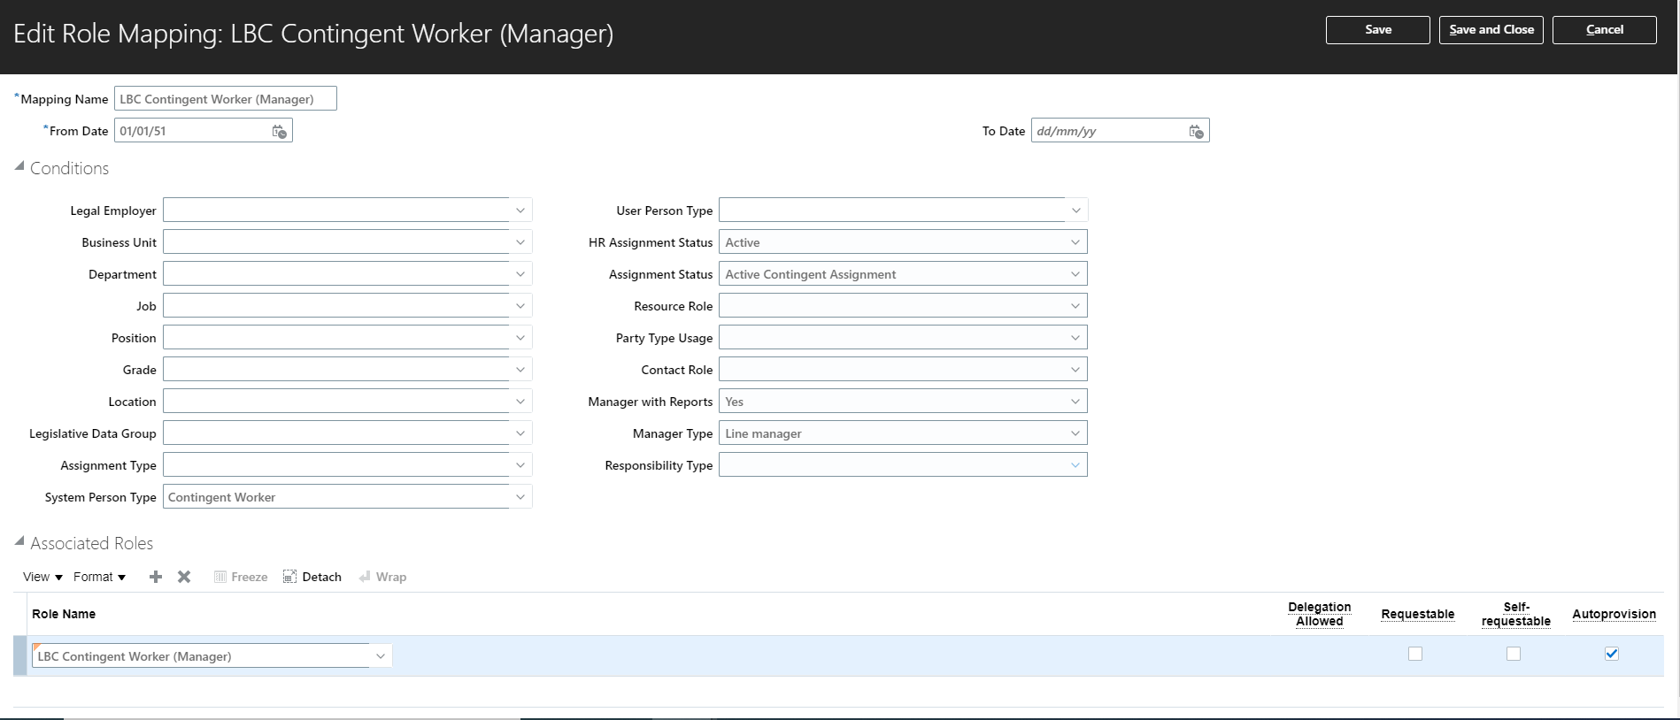

## LBC Hiring Manager

**Role Name**: LBC Hiring Manager

**Role Code**: LBC_IRC_HIRING_MANAGER_ABSTRACT_CUSTOM

This role is an abstract role, created by copying seeded Hiring Manager role. This role will be auto provisioned to all the managers who have direct reports. This role allows managers to use Hiring Area under My Team. This allows hiring manager to create requisitions and manage candidates.

**Role Details:**

* LBC Hiring Manager role is created by copying seeded Hiring Manager Role. Please find below attached excel sheet with list of Privileges and Duty Roles



**Autoprovision Rule:** LBC Hiring Manager role will be added to the LBC Contingent Worker (Manager) role mapping rule & LBC Line Manager role mapping rule.

**LBC Contingent Worker (Manager) Mapping Rule**

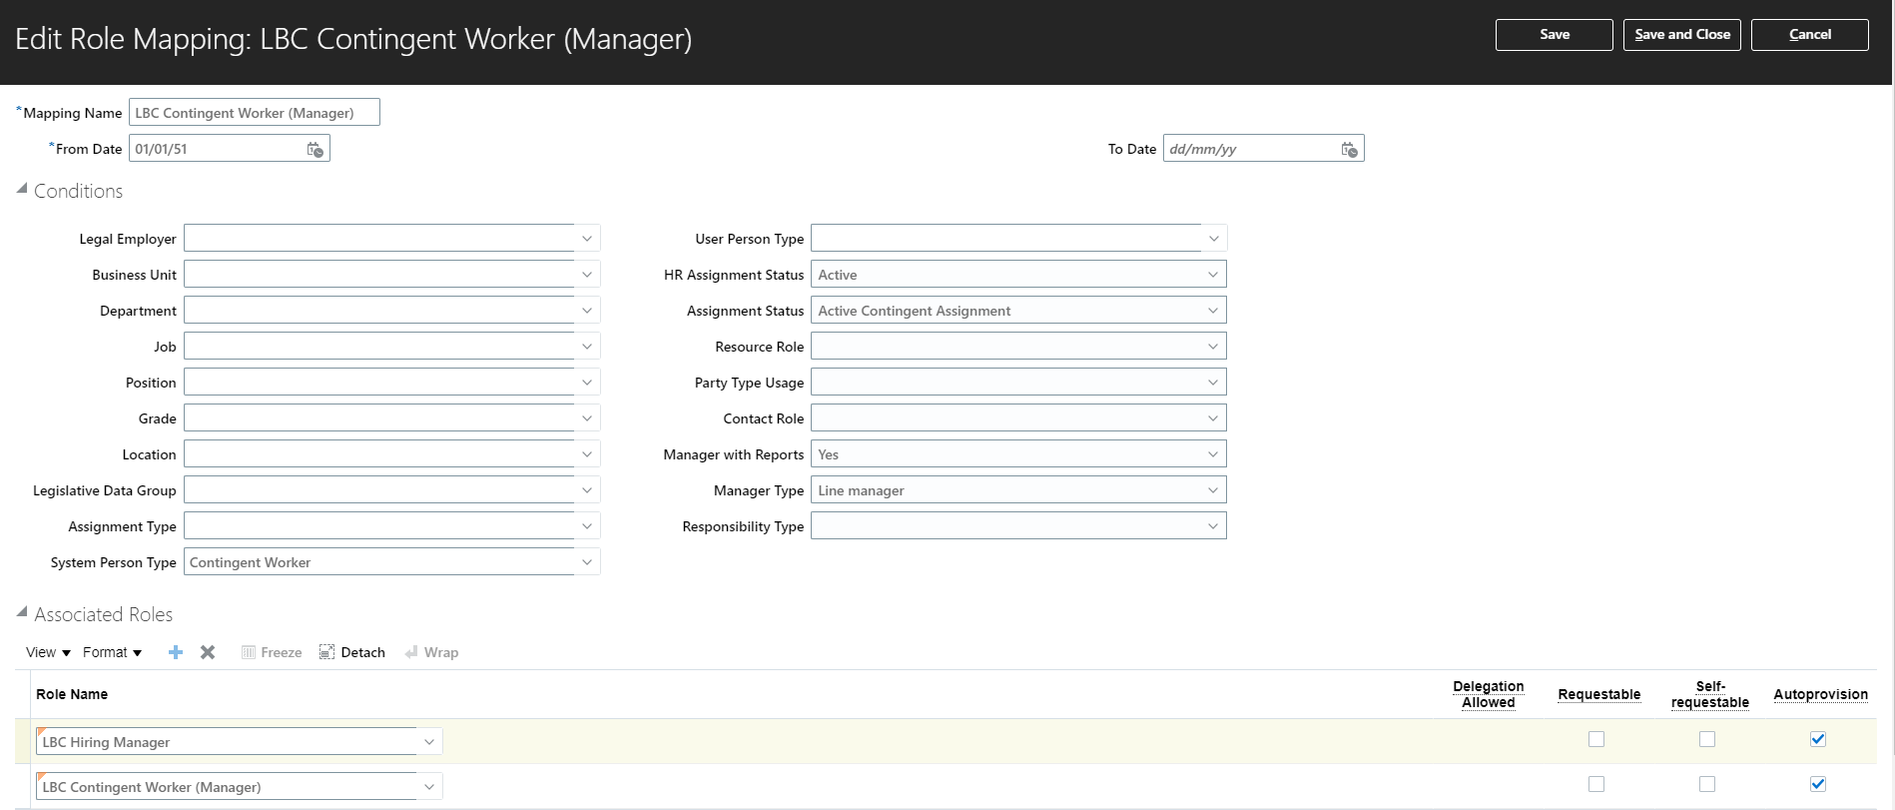

**LBC Line Manager Mapping Rule**

## LBC Line Manager

**Role Name**: LBC Line Manager

**Role Code**: LBC_LINE_MANAGER_DATA

**Inherited Job Role:** Line Manager Role

This role is already available to all the managers but to use Oracle Recruiting Cloud functionality, additional roles and privileges have been added which are mentioned below. These additional roles and privilege will now allow the contingent workers to access the Onboarding Page which helps contingent worker managers to perform below tasks

* Access Onboarding tasks of the subordinates

**Role & Privileges added to Job Role ( Manager Role)**

Roles:

1. Manage Onboarding by Manager

Privileges:

1. Manage Onboarding by Manager

## LBC Collaborator

**Role Name**: LBC Collaborator

**Role Code**: LBC_IRC_COLLABORATOR_ABSTRACT_CUSTOM

This role is an abstract role, created by copying seeded Hiring Manager role. This role is assigned automatically to those employees/contingent workers who are added as Collaborator on the requisition page. This role provides access to Hiring area under My Team, which allows collaborators to perform below tasks:

* View only those requisitions on which user is added as collaborator,
* View candidate application of those candidates who have applied to requisition on which user is added as collaborator
* This role will not allow the collaborator to create/update interview schedule

**Role Details:**

* LBC Collaborator role is created by copying seeded Hiring Manager Role. Please find below attached excel sheet with list of Privileges and Duty Roles



**Auto provision Rule:** This role will not be auto provisioned and will be automatically added to the users who are added as collaborator to the requisition with the help of a report run at the backend.

**Note: The steps will be added once the report is ready. The report will not remove the role automatically, we will create a new report which will show the list of all collaborators for the closed requisitions. This can be used to manually remove the collaborator role from the employee.**

## LBC Recruiter

**Role Name**: LBC Recruiter

**Role Code**: LBC_RECRUITER_DATA

**Inherited Job Role:** LBC Recruiter Custom Job

This role will be auto provisioned to Resourcing Advisors and Co-Ordinator’s using which they can monitor complete Recruiting Process end to end. With this role users can perform these activities at high level

* Create/Update Requisitions
* Post Job Requisitions
* Manage Candidate Application Process
* Create new Questions
* Create Job Offer
* Extend Job Offer

**Role Details:**

Please find attached excel sheet with list of roles and privileges



**Autoprovision Rule:**

LBC Recruiter Role will be auto provisioned to those employees who belong to any of the below departments:

* Human Resources - Business Advisors
* Human Resources - Expert Advisors
* Human Resources - Resourcing
* Human Resources Strategic Leads

Please find below screenshot with the auto provisioning rules.

**Human Resources - Business Advisors**

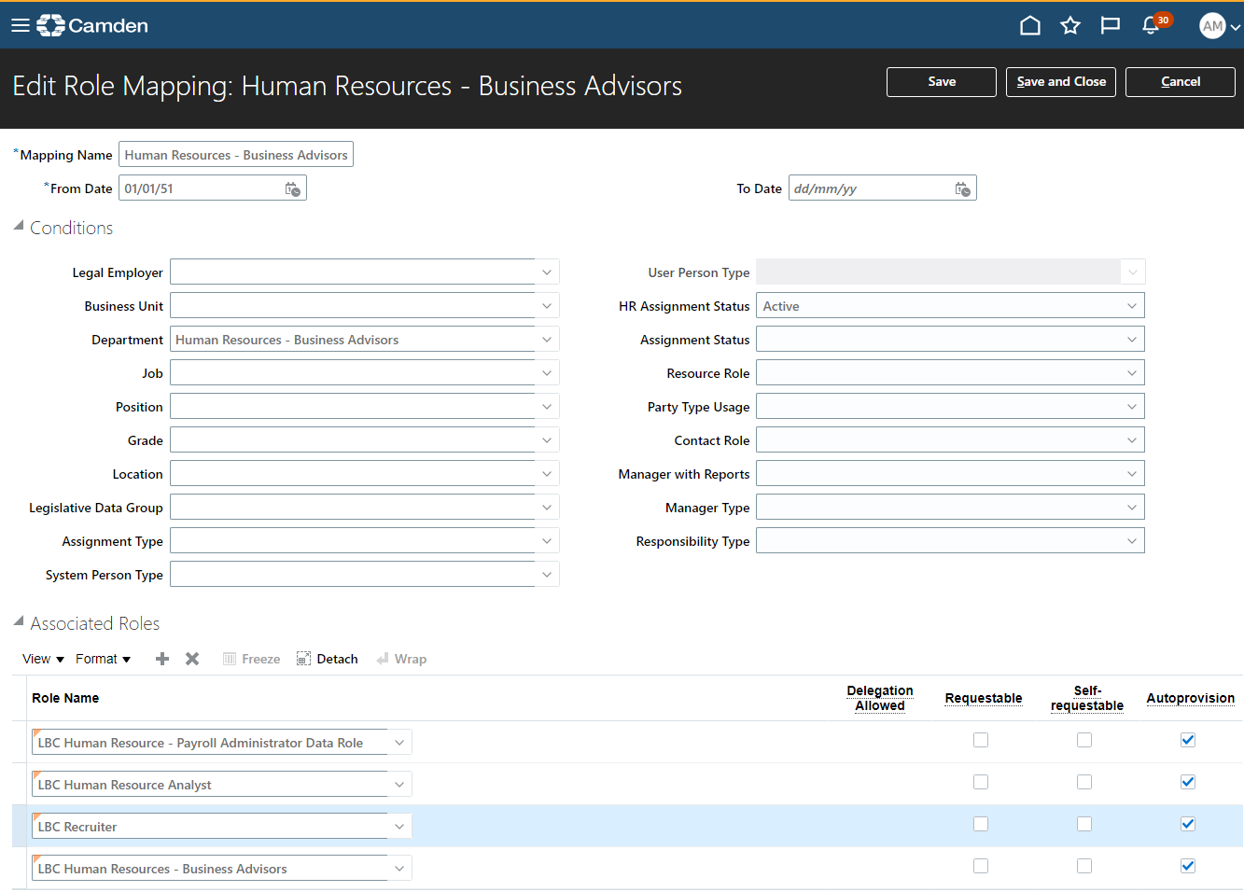

**Human Resources - Expert Advisors**

**Human Resources – Resourcing**

## LBC Recruiting Administrator

**Role Name**: LBC Recruiting Administrator

**Role Code**: LBC_RECRUITING_ADMINISTRATOR_DATA

**Inherited Job Role:** LBC Recruiting Administrator Custom Job

This role provides access to the setup side of the Oracle Recruiting Cloud. Users with role will be able to configure components of ORC including the Candidate Selection Process, Application Forms, Questions, Notification templates.

**Role Details:**

Please find attached excel sheet with list of roles and privileges



**Autoprovision Rule:**

This role will not be auto provisioned and will need to be manually added to the required users.

## LBC Recruitment Reporting

**Role Name**: LBC Recruitment Reporting

**Role Code**: LBC_RECRUITMENT_REPORTING

This role provides access to Oracle Recruiting Cloud subject areas. Users with this role will be able to create and run ORC reports.

**Role Details:**

Please find attached excel sheet with list of roles



**Autoprovision Rule:**

This role will not be auto provisioned and will need to be manually added to the required users.

## Security Profiles for New Roles Created

We have not created any new security profile as part of newly created roles.

## EQuest

The ORC User Account with Person ID (required for authentication/validation) should be assigned the following roles and privileges*

**1. Role Name**: Application Implementation Consultant

**Role Code**: ORA_ASM_APPLICATION_IMPLEMENTATION_CONSULTANT_JOB

**Inherited Job Role:** NA

This role should be attached to the ORC User Account to perform the integration export/import in ORC.

**Role Details:**

Please find attached excel sheet with list of roles and privileges



**2. Role Name:** LBC Recruiter: Please Click here

This role has Post Job Requisition to Job Distributor's Portal privilege added which is required for job distribution.

**3. Role Name:** LBC Recruiting Administrator: Please Click here

This role is required to access the Recruiting and Candidate Experience Management > Recruiting Category Provisioning and Configuration to enable eQuest & storing reference key.

# Open Issues

|  |  |  |  |  |  |  |
| --- | --- | --- | --- | --- | --- | --- |
| Sr. No | Issue | Resolution | | Responsibility | Target Date | Impact Date |
| 1 |  |  |  | |  |  |
| 2 |  |  |  | |  |  |
| 3 |  |  |  | |  |  |
| 4 |  |  |  | |  |  |
| 5 |  |  |  | |  |  |
| 6 |  |  |  | |  |  |

# Closed Issues

|  |  |  |  |  |
| --- | --- | --- | --- | --- |
| ID | Issue | Resolution | Responsibility | Completion Date |
| 1 |  |  |  |  |
| 2 |  |  |  |  |
| 3 |  |  |  |  |